**ST. XAVIER’S COLLEGE**

**(Affiliated to Tribhuvan University)**

**Maitighar, Kathmandu**



**SIMULATION AND MODELING LAB REPORT #04**

**SUBMITTED BY:**

Pradeep Dahal

017BSCIT029

3rd year/ 5th Sem

|  |  |
| --- | --- |
|  | Signature |
| Mr. Ganesh Yogi  (Lecturer) |  |
| Department of Computer Science | |

**SUBMITTED TO:**

**TITLE: TO FIND THE VALUE OF PIE BY MONTE-CARLO METHOD IN EXCEL.**

**THEORY:**

Monte Carlo simulations are used to model the probability of different outcomes in a process that cannot easily be predicted due to the intervention of [random variables](https://atlas.dotdash.com/terms/r/random-variable.asp). It is a technique used to understand the impact of risk and uncertainty in prediction and forecasting models.

Monte Carlo simulation can be used to tackle a range of problems in virtually every field such as finance, engineering, supply chain, and science.

Monte Carlo simulation is also referred to as multiple probability simulation.

**RESULT:**

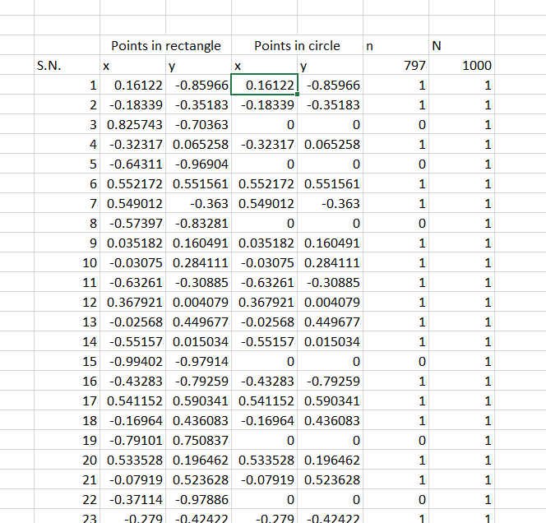

For x, the formula in the excel sheet is given by:

=RANDBETWEEN(-100000000,100000000)/100000000

For y, the formula in the excel sheet is given by:

=RANDBETWEEN(-100000000,100000000)/100000000

**CONCLUSION**

Hence, the value of pie with the monte- carlo method has been found in the Microsoft Excel. The observed value of the pie is given by 3.116.